**EDUNLP: AI-DRIVEN LECTURE SUMMARIZATION AND INTERACTIVE**

**LEARNING WITH CONTEXT-AWARE QUESTION GENERATION**

**KAVYA M 1**

[e5222044@sret.edu.in](mailto:e5222044@sret.edu.in)

**SRI RAMACHANDRA INSTITUTE OF HIGHER EDUCATION AND RESEARCH**

**ABSTRACT**

This paper explains the development of AI powered Natural Language Processing (NLP) system aimed for automated lecture summarization parallel with interactive question and answering and customized educational support features. This system employs transformers T5 for multi- language summarization along with Distil Bert for question and answering system and spacy for named entity recognition (NER) to extract, process and summarize the information from various sources like datasets and pdf into a detailed lecture summaries. This paper incorporates a TF-IDF based keyword extraction module along with multi language text to speech conversion capabilities and sentiment analysis tools for user input review. Through the generation of interactive flashcards containing MCQ'S (multiple choice questions), this system increases user interaction. This AI-driven system shows excellent results over manual methods by achieving greater speed, accuracy and scalability. This system Processes large volumes of text with exceptional speed, providing precise, context-aware responses. This digital learning platform aims to Supports long-term knowledge retention along with improved access and user engagement functionalities. This paper showcase how NLP based tools can perform teaching methods enhanced by automated summarization and AI-powered tools. This system’s Expertise in processing large datasets and delivering precise results is supported by Factual evidence. Future progress covers real-time summarization along with adaptive learning mechanisms to deliver personalized content.

**KEYWORDS**: *Natural Language Processing (NLP), Text -to-Speech, Lecture Summarization, Interactive Learning.*

**1.INTRODUCTION**

In the era of online education, the rising volume of online lectures and study materials hinders the ability to retain and access information. The conventional summarization and knowledge retrieval demands considerable effort and time, making AI-based solutions essential for simplifying the learning experience. This paper Showcases EduNLP, an AI-powered NLP system platforms that aims to improve and increase digital learning through automated lecture summarization, question-answering, and interactive learning support. By leveraging cutting-edge deep learning models, EduNLP extracts, processes, and condenses educational material into valuable summaries using the T5 Transformer model. It also Implements Distil BERT for question-answering and spacy for Named Entity Recognition (NER), supporting reliable information retrieval. The system further incorporates TF-IDF based keyword extraction, multi-language text-to-speech (TTS) conversion, and sentiment analysis to boost user participation and accessibility. Furthermore, a Dynamic module for flashcard generation is presented, creating multiple-choice questions (MCQ's) to improve learning outcomes. The recommended framework Works to strengthen e-learning by providing an AI-assisted, engaging, and effective platform for acquiring knowledge. This paper examines the strategies, application, and outcomes of AI-powered educational tools, demonstrating their potential to boost student interest and tailored learning experiences.

* 1. **PROBLEM STATEMENT**

With the active expansion of online education, both learners and instructors deal with issues in understanding, recalling, and organizing wide-ranging lecture content, research papers, and learning materials. Customary approaches, such as is manual summarization or note-taking, and question generation, tend to be time consuming or inefficient, and prone to human errors. Additionally, Language barriers, as well as accessibility, obstruct that learning process. Existing summarization and knowledge retention practices offer little flexibility and provide no personalized, stimulating educational aid. Furthermore, customary learning tools usually lack AI-powered functionalities, including automated text summarization, question-answering, flashcard generation, and sentiment-based learning observations, which results in decreased enthusiasm and awareness for learning. This paper addresses these limitations in that it proposes EduNLP; an AI-driven NLP solution strives toward automated lecture summarization, question generation, and interactive learning. Such a solution works toward these goals. Employing deep learning techniques, for instance, T5 Transformer, Distil BERT, and spacy, the system improves educational experiences, in addition to offering real-time summarization, keyword extraction, multilingual text-to-speech synthesis, and adaptive learning approaches. The solution has aims to transform digital learning via mitigation of cognitive load, improvement of accessibility, and cultivation of an engaging learning atmosphere through automation that is AI-driven.

**1.2** **OBJECTIVE**

EduNLP is an initiative towards developing an NLP (Natural Language Processing) based solution to revolutionize digital education which powered by AI. Specialty: Automating lecture summaries, answering questions, and providing interactive learnings. It will use a T5 Transformer for summarization of academic content, a Distil BERT for the question-answering component, and an automatic flashcard system that generates multiple-choice questions (MCQ) for the learning reinforcement. Additionally, the project will apply TF-IDF and Named Entity Recognition (NER) using spacy to extract keywords, a multi-language Text-to-Speech (TTS) system to help visually impaired learners, sentiment analysis to adjust content delivery according to feedback, and an adaptive learning assistant to personalize content helping users to stay engaged and understand better. Their goal is to facilitate greater access to digital education via bridging gaps and breaking down more complex lecture materials into cycles that are more accessible and easily engaged.

* 1. **LIMITATION**

As helpful as that may be, the EduNLP system is even limited in: and we should bear this in mind despite advancing its high applicability in the field (i.e., NLP application) through the automation of lecture summaries and interactive learning with an AI-powered NLP. First, the performance of either text summarization, or question-answering is largely based on user-provided data, and the structure of that data. Catastrophic forgetting makes it less reliable over time and poorly formatted or ambiguous content can cause inaccurate or incomplete summaries. Besides, the challenge of context preservation remains – it is not uncommon for deep learning models to produce outputs – summaries or answers with loss of coherence, missing critical nuances (T5 Transformer, Distil BERT) Deep learning also has some limitations, for example, it needs more processing power and memory which may become an issue for low-end devices with constraints while applying these algorithms in real-time correspondingly. In addition, multi-language TTS conversion may lead to pronunciation correctness and naturalness problems, due to the limitation of resources for less popular languages. The system also makes use of pre-trained models which can learn the biases of the training data and negatively impact fairness & inclusivity of learning materials. Additionally, sentiment analysis and adaptive learning personalization require sufficient user interaction data, potentially taking time to be effective. Finally, privacy is a huge concern with data, being stored and processed within a sensitive educational environment can present its own needs we need to meet. In future advancements, gpt 4 is advancing those to provide more contextual understanding, lower computation costs and better bias mitigation for a more effective learning experience.

**2. LITERATURE REVIEW**

Natural Language Processing (NLP) is applied widely in education technology for the automation of content understanding, generation of tests, and adaptive learning with increased interaction. A wide range of research has been carried out on several applications of NLP for education. In computer question-answering Ling and Afzaal (2024) demonstrated the capacity of pre-trained huge Language models in generating structured tertiary-level Q&A pairs. Afrizal et al. (2024) also utilized Indonesian BERT for a chat service to assist learners with more correct and suitable answers. Sammoudi et al. (2024) developed a QA system for an Arabic language learning personal assistant, and Khondoker et al. (2024) examined the use of different BERT models in Bangla question answering, proving the feasibility of language models in native languages.Text summarization, one of the primary NLP tasks in summarizing scholarly content, has been enhanced with transformer-based models. Wang et al. (2023) showed a T5-based summarization model with semi-supervised learning and consistency loss that made significant improvement in relevance and coherence. Akram Sawiras (2024) shared new summarization techniques using Retrieval-Augmented Generation (RAG) and Small Language Models (SLMs), highlighting their applicability to educational settings.  
The development of automated quiz and question generation software has enabled large-scale educational testing to become a reality. Bhowmick et al. (2023) and Gabajiwala et al. (2022) proved that NLP-based quiz generation systems could successfully convert scholarly content into structured tests such as multiple-choice questions.

Some other works in this direction include tools like Eduassesspro (Khairkar et al., 2024) that automate quizzes and examinations, and systems proposed by Bongir et al. (2018) and Mondal and Rabbi (n.d.) in order to automate evaluation processes. Multilinguality support and accessibility have been major research issues, as well. Das et al. (2023) conducted a comparative study of cross-lingual sentiment analysis from conventional and hybrid deep learning models, while bringing out the strength of NLP for multilinguality systems. Kulkarni et al. (2024) presented a multilingual speech conversion system with real-time processing in order to facilitate further language inclusiveness. Sun and Nagamatsu (2020) also suggested a cross-lingual voice conversion method to create multilingual text-to-speech models to make content more accessible. Nevertheless, natural language complexity remains a problem  
Khan et al. (2016) built on the intricate relationship between syntax and sentiment in language modeling, with an invitation to deeper linguistic analysis in intelligent educational systems. These studies collectively provide a solid foundation for the integration of NLP modules such as summarization, translation, question generation, and speech synthesis into a single application. The current study builds on this background by incorporating these features into an interactive, accessible, and education-focused NLP application that supports personalized and automated learning exercises.

**3. PROPOSED METHODOLOGY**

**3.1 OVERVIEW OF THE METHODOLOGY**

The proposed methodology introduces a smart, flexible, as well as scalable NLP pipeline that brings customary lecture materials into the digital age. The central goal involves making learning a more interactive, engaging, and easier sort of process to understand through automating particular key tasks like summarizing content, answering questions, generating MCQs, analyzing sentiment, and converting text to speech, all throughout support for multiple languages. This system combines the power of modern Supervised learning and neural-based models. It wraps it in a clean, user-friendly web app built with Flask. It is designed to give a smooth and accessible experience for both learners and educators.

**3.2 INPUT LAYER – UPLOADING AND PARSING EDUCATIONAL MATERIALS**

The first step involves the Input Layer where users Usually, students or teachers upload their course content most often in PDF format. PDFs are commonly utilized in educational platforms for distributing lecture notes, presentations, and study guides aligning them well with the system’s input needs. Once a PDF is uploaded, the system kicks in and uses powerful text extraction libraries to carefully read and pull out the content. But it doesn’t just grab everything it smartly filters out distractions like page numbers, headers, footers, and odd formatting symbols that don’t add value to the learning experience. The result is a neat, systematic block of text that’s ready for the next stages of processing. This step ensures that only the meaningful, relevant parts of the material are retained by providing a firm base for advanced NLP technologies tasks that follow.

**3.3** **LANGUAGE DETECTION, TRANSLATION & PREPROCESSING – PREPARING THE CONTENT FOR ANALYSIS**

After Isolation of textual content from uploaded given PDF file, the system Enters another important phase: understanding content language. The automation starts with a language identification mechanism, employing tools such as language-detector the advanced transformer models that are able to clearly identify the language. As soon as the system identifies that there is a different language other than the intended language selected by the user, the system automatically calls for translation. The Google Translate API and multilingual transformer models handle this, making the content available to people with various languages spoken across the world. After this is done, in the appropriate language, it's passed into a strong text preprocessing pipeline in order to cleanse and prepare the same for further high-level analysis. This involves several behind-the-scenes processes. The system then divides the content into smaller meaningful units like words and sentences in a process of tokenization. Then, It removes common words like "the," "is," and "and" that do not have a significant role to play in understanding, in a process of stop word removal. Then, words are converted to their root word using lemmatization to ensure uniformity even if multiple forms of the same word are used. Finally, text normalization is done, wherein the text is normalized by changing it to lower case, removing the punctuation, and eliminating any excess spaces. All these preprocessing steps make sure that the text is clean, structured, and ready for the system's intelligent NLP models to work their magic in the next phases.

**3.4 SUMMARIZATION AND QUESTION ANSWERING – MAKING LEARNING EFFICIENT AND INTERACTIVE**

Once the text has been cleaned and prepared the system goes on to one of its most important features: simplifying the Processing and grasping extensive academic content The first module involved in this effort is the Summarization Module, which is the basis for helping users learn the gist of their lectures at a glance. Instead of only pulling out major sentences as regular extractive techniques, this step uses abstractive summarization using high-end transformer models such as BART, T5, or Pegasus. They learn to effectively understand the context and generate totally new sentences paraphrasing the text with all the major concepts. This means students can learn long and complex topics much faster, especially when preparing for studying or exams. Complementing the summarization is the Question Answering (Q&A) Module, which makes reading a fun activity. One can just ask questions about what they have uploaded, and the system responds with context-dependent, correct answers. This is possible through powerful BERT-based Transformer-based models like BERT-large that have been adapted using the extensively used Squad dataset. These models have the ability to read and understand both the question inquired by the user and the question context simultaneously. Through their transformation into semantic form and the application of attention mechanisms, the system recognizes the most relevant span of text that best answers the query. Along with the summarization and Q&A modules, there is a dynamic learning experience one that is time-saving, improves understanding, and actively engages users with their study materials.

**3.5 INTERACTIVE ENGAGEMENT THROUGH MCQ GENERATION, SENTIMENT ANALYSIS, AND TEXT-TO-SPEECH**

To facilitate better learning through active rather than passive reading and comprehension, the system comprises an interactive suite of modules to foster active participation and ease of access. MCQ Generation Module forms the cornerstone for the promotion of self-testing and knowledge retention. Employing Named Entity Recognition (NER) methodology, the system identifies significant concepts, terminologies, dates, and definitions from the summarized text. Based on these observations, it actively generates different types of questions like "wh"-type questions and fill-in-the-blank ones that try out students to recall and apply information in context. To ensure such tests are pedagogically sound and motivating, the system cleverly generates distractors or probable wrong answers on the basis of lexical databases such as WordNet and generative models such as GPT, thereby inducing critical thinking and limiting the scope of random guessing.

Sentiment Analysis is integrated along with this module providing significant results to Learner participation and material intake. By utilizing transformer-based models such as distilbert-base-uncased-finetuned-sst-2-english, the site examines text inputs in either mode of user feedback or lecture content to ascertain sentiment as positive, neutral, or negative. All such analytics make teachers more informed about learners' emotional reactions and enable data-based adjustment of learning methods and the quality of learning content.  
Moreover, the website offers a Text-to-Speech (TTS) functionality which was implemented to enhance accessibility and to support adaptive learning approaches. With Google Text-to-Speech (gTTS) or pyttsx3 as tools, the system translates textual content like summaries, answers, and MCQs into high-quality audio outputs in audio formats such as MP3 or WAV. This is of huge advantage to the visually impaired and blind people, as it allows access to material on the move or in a scenario with multiple stimuli. The audio can be streamed from the online interface or downloaded to be accessed offline, rendering learning an easily accessible option.

**3.6 WEB-BASED USER INTERFACE (UI)**

All and each module of the system is neatly wrapped within a friendly, central web interface built on the Flask platform. The user-centric, usability-centric interface shows an interactive, continuous stream which plots users at all stages of the NLP pipeline. Users can upload PDF lecture material smoothly at the initial point itself, triggering the processing pipeline. The website also has a language option feature, through which the users can communicate with content of their preferred language, thereby meeting a multilingual audience. The processed summarized content is then presented in a clean manner, accompanied by an interactive Q&A section, where users can ask questions and receive smart answers from the uploaded content. The platform further enhances interactivity through multiple-choice questions (MCQs) for self-test drives, and a feedback area through which users can comment upon their experience, that may help instructor administer refine content and presentation. Towards inclusive accessibility, especially for auditory learners, the interface also provides audio playback of generated content, with the ability to download audio files to access offline. On the whole, the design's simplicity guarantees that even individuals with limited technical knowledge can easily navigate and utilize the platform effectively, thus making it an effective tool for modern, AI-driven learning.

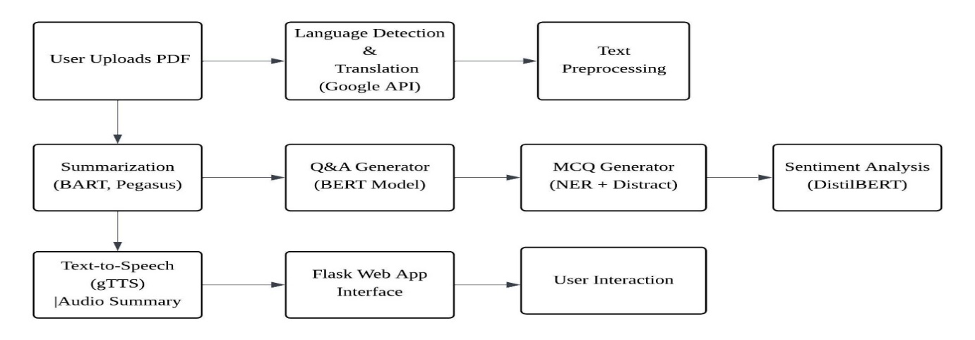

**FIGURE 1: PROPOSED ARCHITECTURE**

**4. EXPERIMENTAL RESULTS AND DISCUSSION**

The deployed NLP-based software illustrated robust and useful performance by carrying out a large variety of tasks of language processing integrated into one, thereby laying bare its actual utility as an all-purpose pedagogic assistant system. The system had and effectively deployed modules for PDF extraction of text content, text summarization, text-to-speech synthesis, translation of language, context-dependent answering of questions, flashcard making, and automatically generating examination questions.

Rather than being measured using traditional machine learning metrics such as accuracy, precision, or recall, the system performance was derived from large-scale functional testing, qualitative output analysis, and human-centered case studies. This dovetailed with the focus on information transformation, human interaction, and learning facilitation, where usability, coherence, and output quality are preferred to brute numerical results.  
The PDF text extraction component handled well various types of documents, including digitized native PDFs and scans. For PDFs scanned, fallback OCR facilities enabled the content of the text to be harvested and reused downstream in NLP processing. The summarization model, which relied on a transformer model, generated concise and readable abstracts for extremely long scholarly documents. These abstracts preserved the essential semantic content of the original material, and they were useful for quick content review and understanding.

The speech synthesis module, using the Google Text-to-Speech (gTTS) library, read extracted or summarized content as natural-sounding speech. The ability added significantly to the accessibility of educational content for visually impaired users or for users who understand better when they hear. Speech generated was understandable, natural-sounding, and at normal pace, with minimal generation latency. The translation of languages function also offered multilingual support by translating the academic content to the target languages accurately. This enabled the app to provide a linguistically diverse user base, provide academic content to non-native English users, and enable global adoption of the tool.

One of the major innovations of the system is automated question generation from the module, which produced grammatically well-formed questions over a spectrum of complexity: MCQs, short-answer type (2-mark and 3-mark), and long-answer (5-mark) types. Questions produced were both contextually appropriate and syntactically accurate and representative of underlying concepts from input documents. MCQs included well-thought-out options with one correct and plausible distractor answer, thus preserving pedagogical value. Short and long questions according to standard academic testing and encouraged more mental engagement with the material.  
The flashcard creation tools comprised automatically generated revision cards from the content summaries. The flashcards supported interactive learning by exposing users to main concepts and allowing self-testing in question-and-answer format. The function was especially supportive of exam revision and remembering information. The question answering (QA) system provided users with the ability to ask natural language questions based on the uploaded documents. Answers were generated from the summarized content rather than the full text, ensuring speed and relevance while reducing noise. The responses were contextually appropriate, grammatically correct, and semantically accurate in most cases, reflecting the model’s strong comprehension capabilities.

Informal user testing and feedback indicated high satisfaction with the application’s utility, ease of use, and versatility. Educators highlighted its potential for automating assessment preparation, while students appreciated the interactive elements such as flashcards and TTS. Overall, the application demonstrates how a well-integrated NLP system can transform static educational materials into dynamic, interactive, and accessible learning tools. The results strongly affirm the system’s practicality, usability, and adaptability in modern e-learning environments, especially in contexts where scalable automation of content understanding and learning support is essential.

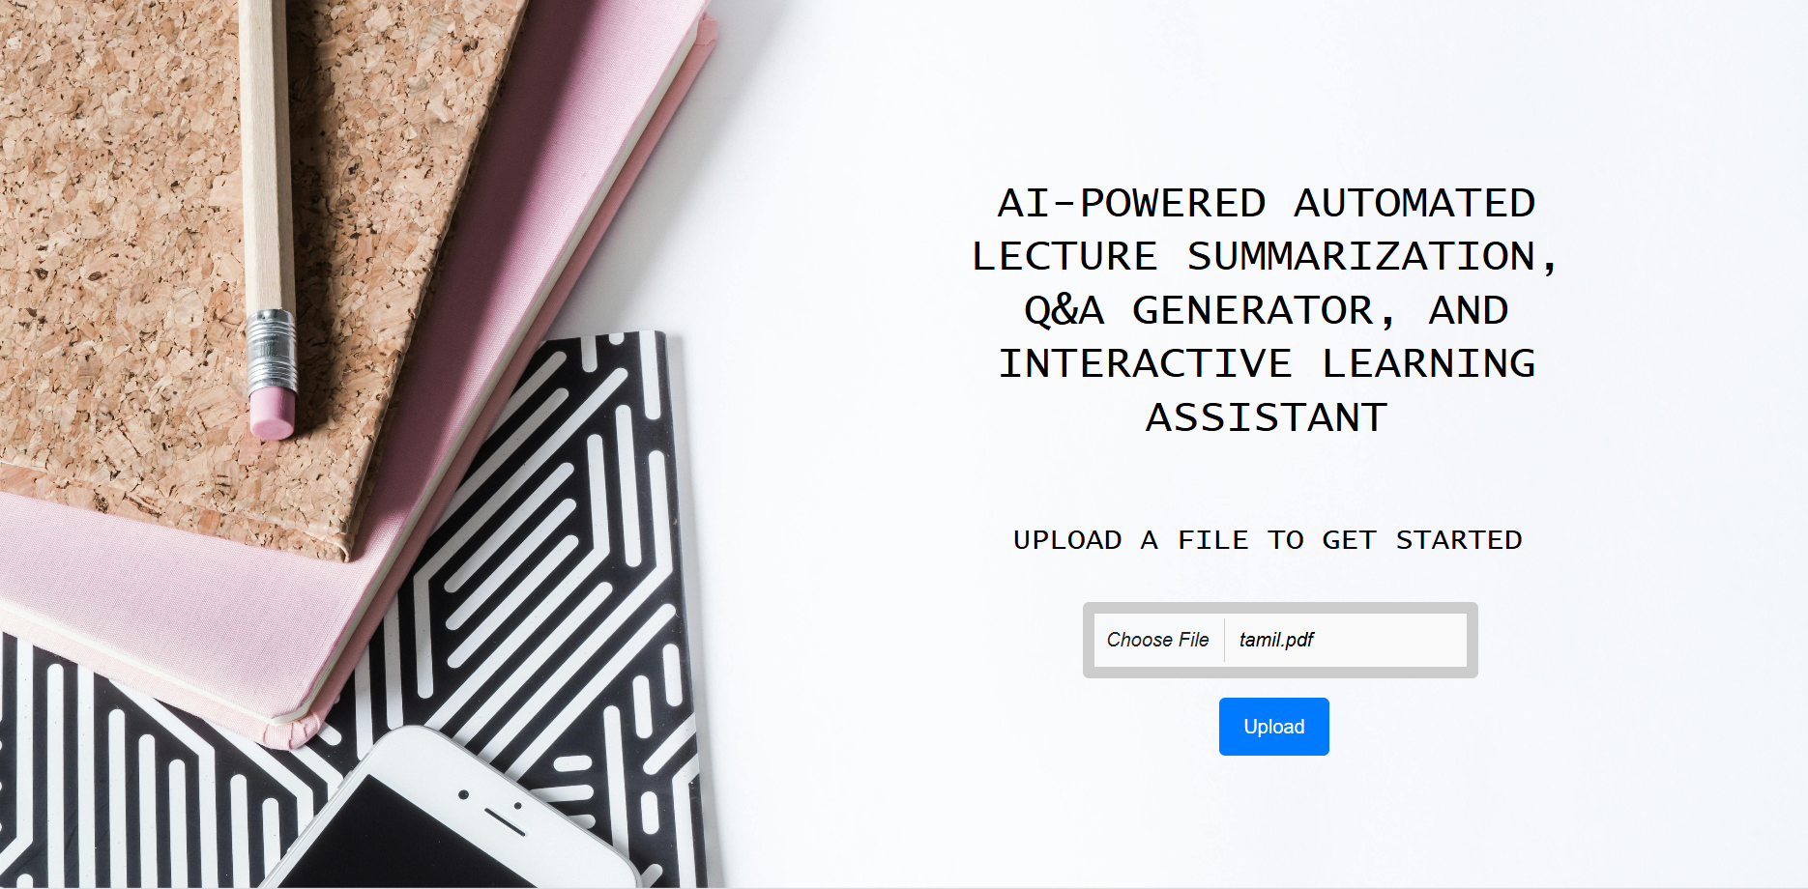

**FIGURE 2: AI-Powered Educational Assistant Interface for Lecture Summarization and Q&A Generation**

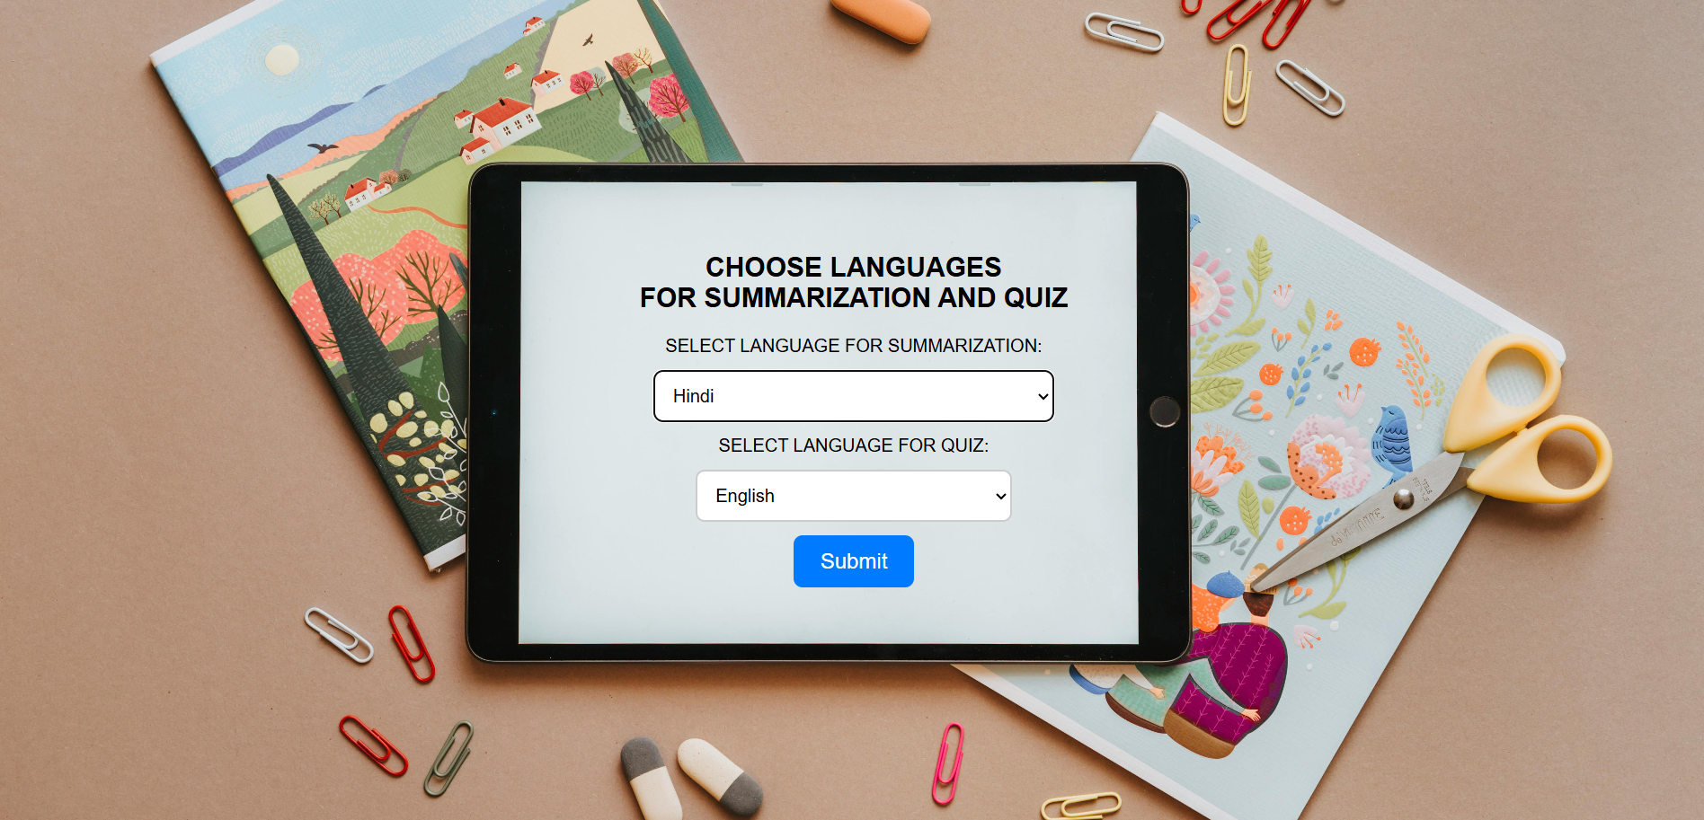

**FIGURE 3: Multi Language Selection Interface for AI-Based Lecture Summarization and Quiz Generation**

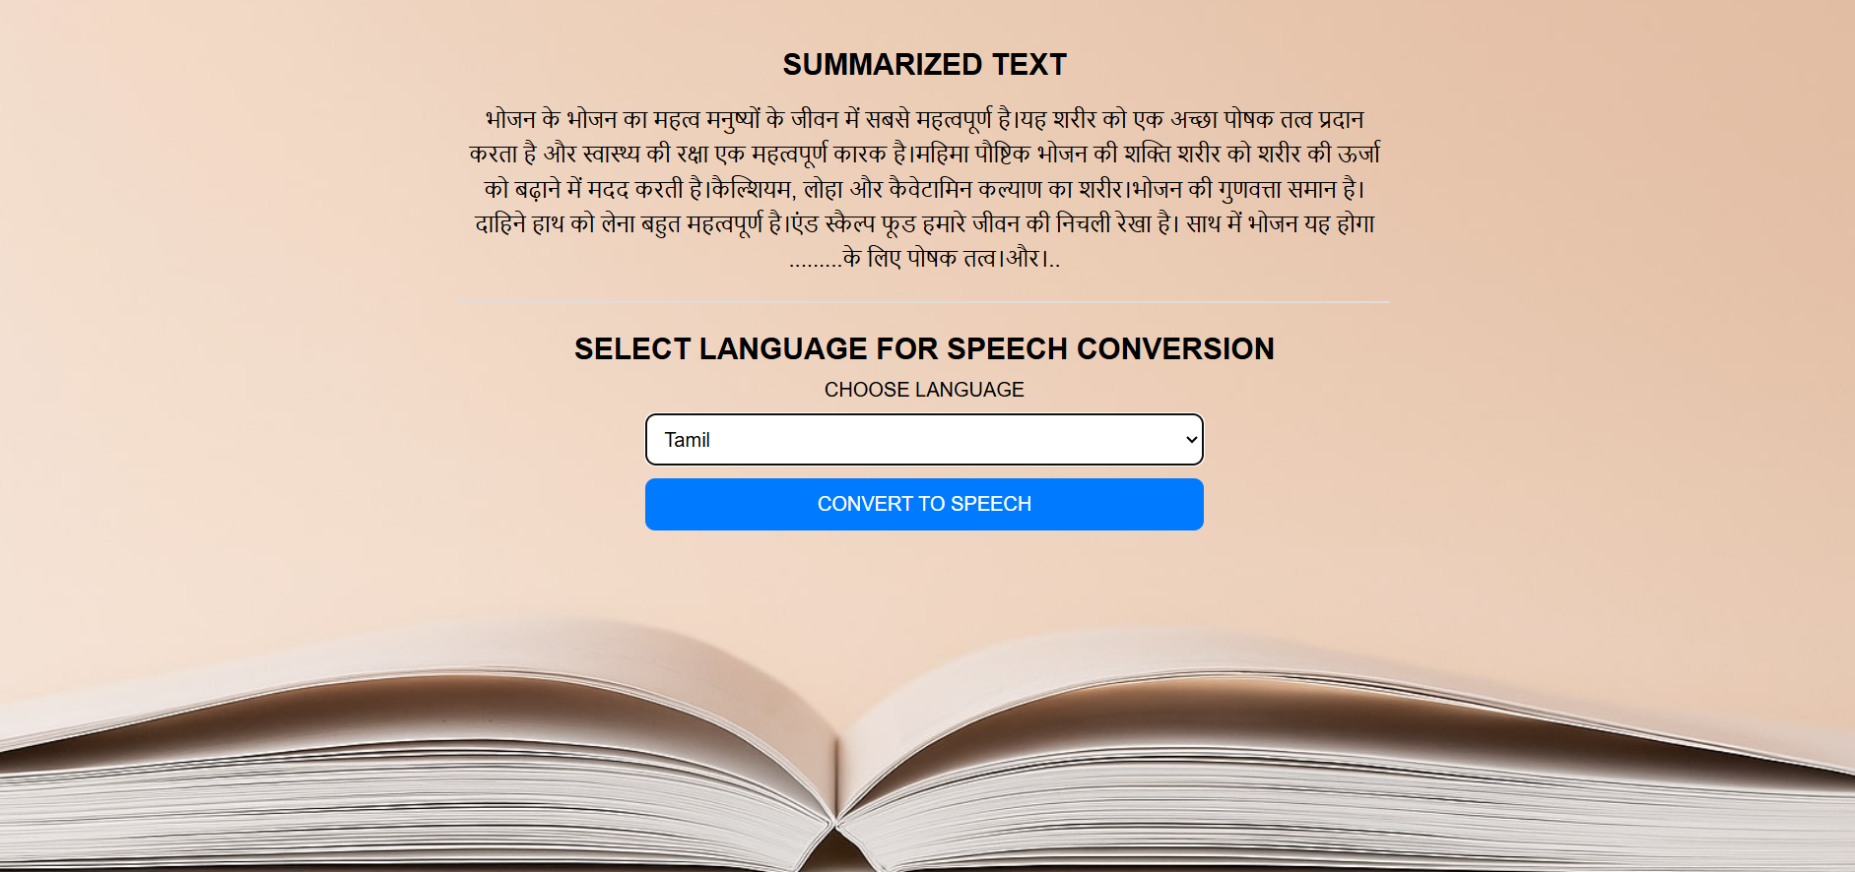

**FIGURE 4:** **Multi Language Speech Conversion from Summarized Text**



**FIGURE 5: Summary to Speech with Quiz Integration**

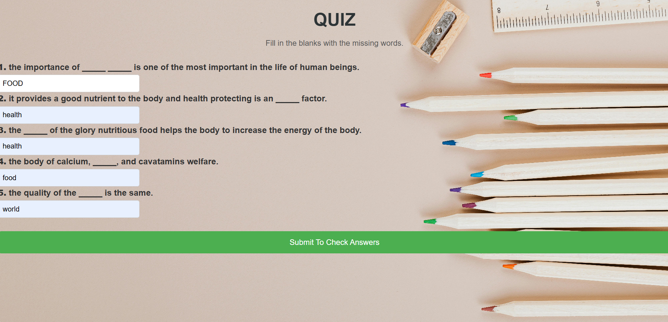

**FIGURE 6: Quiz – Fill in the Blanks Activity**

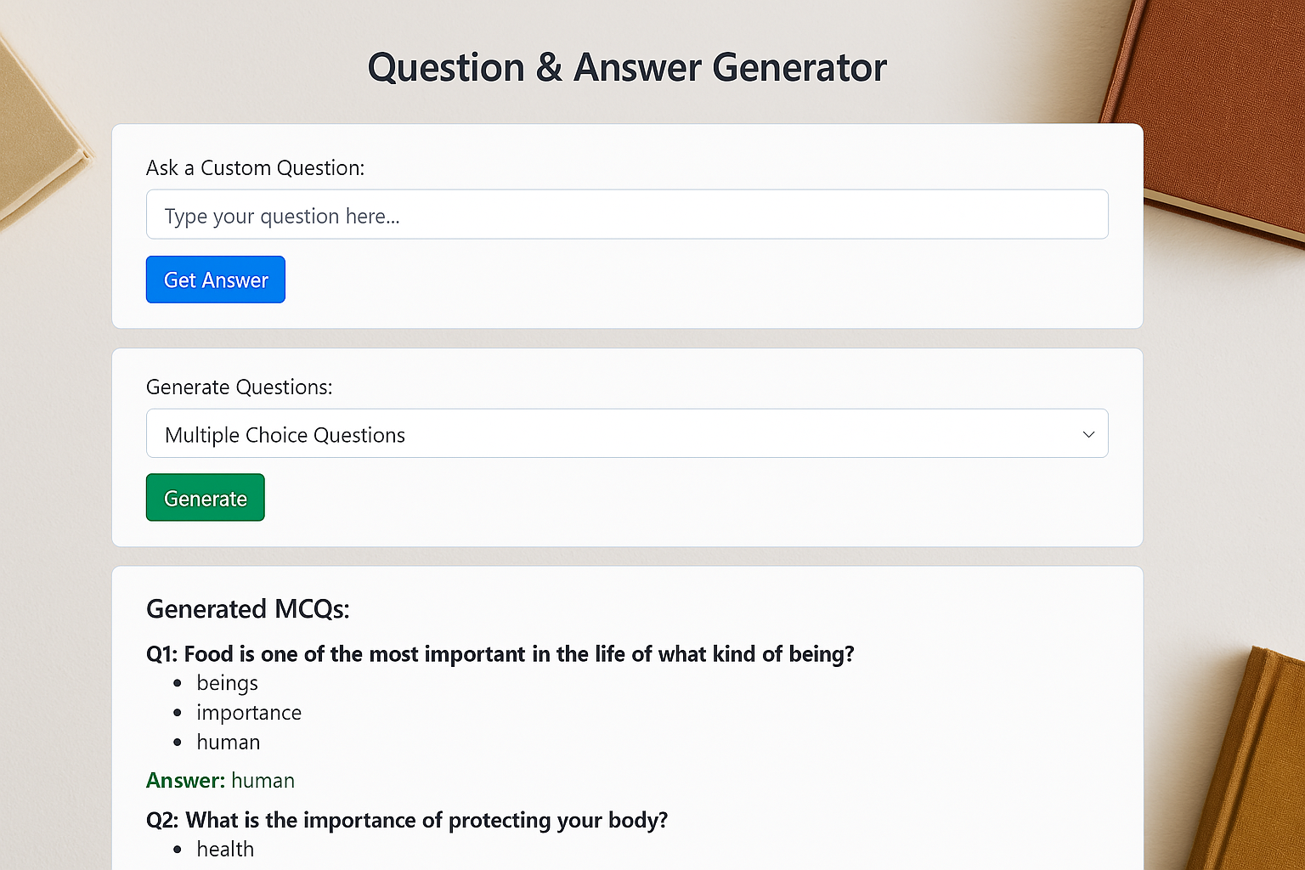

**FIGURE 7: Question And Answers Generator**

|  |  |  |  |  |
| --- | --- | --- | --- | --- |
| **Feature / Objective** | **BERT for Automated QA** | **T5 Summarization** | **Adaptive Flashcards** | **EduNLP** |
| Lecture Summarization | Only uses context retrieval, no summarization | T5-based summarization, limited to English texts | Not included | T5 Transformer for abstractive summarization |
| Question-Answering System | BERT-based QA system | Not included | Not included | DistilBERT for real-time Q&A from lecture content |
| Flashcard / MCQ Generation | Not included | Not included | NLP-based flashcard generation using rule-based templates | Automated flashcard creation (MCQs) from content |
| Text-to-Speech (TTS) | Not included | Not included | Not included | Multi-language TTS to improve accessibility |

**TABLE 1: COMPARISON TABLE**

**CONCLUSION AND FUTURE SCOPE**

The proposed NLP-based learning app effectively integrates many natural language processing operations such as PDF text mining, summarizing, text-to-speech synthesis, translation, flashcard preparation, question-answering, and automatically generating exam questions into a unified, user-driven platform. Qualitative analysis and functional testing substantiated the stability of the performance of the system, effectively transcribing static course materials into active and accessible courses. Its ability to accommodate diverse learning styles and independent learning renders it a highly useful instrument in digital and distance learning contexts.  
For future development, these functionalities can be added to improve the system: adaptive learning based on the user's performance, voice control, live multi-user co-authoring, and gamification for improving the interaction. Other enhancements are diagram and image extraction from PDFs, publishing to mobile apps, and multimodal input support to further improve the accessibility. In addition to automated back-channel feedback and personalized learning paths, the platform also has the capacity to make itself smarter and more tailored to each learner, resulting in a vast AI-driven education assistant.

**REFERENCE**

1. Ling J, Afzaal M. Automatic question-answer pairs generation using pre-trained large language models in higher education. Computers and Education: Artificial Intelligence. 2024 Jun 1;6:100252.
2. Wang M, Xie P, Du Y, Hu X. T5-based model for abstractive summarization: A semi-supervised learning approach with consistency loss functions. Applied Sciences. 2023 Jun 14;13(12):7111.
3. Das RK, Islam M, Hasan MM, Razia S, Hassan M, Khushbu SA. Sentiment analysis in multilingual context: Comparative analysis of machine learning and hybrid deep learning models. Heliyon. 2023 Sep 1;9(9).
4. Akram Sawiras K. Evaluation and Development of Innovative NLP Techniques for Query-Focused Summarization Using Retrieval Augmented Generation (RAG) and a Small Language Model (SLM) in Educational Settings.
5. Afrizal R, Irfan M, Maylawati DS, Atmadja AR, Ramdania DR, Fuadi RS. Efficient Student Academic Support: Leveraging Indonesian BERT for Question Answering in Chat Feature. In2024 12th International Conference on Cyber and IT Service Management (CITSM) 2024 Oct 3 (pp. 1-6). IEEE.
6. Sammoudi M, Habaybeh A, Ashqar HI, Elhenawy M. Question-answering (qa) model for a personalized learning assistant for arabic language. InInternational Conference on Intelligent Systems, Blockchain, and Communication Technologies 2024 Jul 13 (pp. 356-367). Cham: Springer Nature Switzerland.
7. Bhowmick AK, Jagmohan A, Vempaty A, Dey P, Hall L, Hartman J, Kokku R, Maheshwari H. Automating question generation from educational text. InInternational Conference on Innovative Techniques and Applications of Artificial Intelligence 2023 Nov 8 (pp. 437-450). Cham: Springer Nature Switzerland.
8. Khondoker A, Taufik EA, Tashik MI, Parsa AF. Unlocking the Potential of Multiple BERT Models for Bangla Question Answering in NCTB Textbooks. arXiv preprint arXiv:2412.18440. 2024 Dec 24.
9. Kulkarni M, Rathod S, Nemade M, Parbhanikar S, Raut A, Thorat R. Natural Language Processing Approach to Real-Time Multilingual Speech Conversion. InInternational Conference on Artificial Intelligence and Smart Energy 2024 Mar 22 (pp. 276-283). Cham: Springer Nature Switzerland.
10. Sun Q, Nagamatsu K. Building multi lingual tts using cross lingual voice conversion. arXiv preprint arXiv:2012.14039. 2020 Dec 28.
11. Gabajiwala E, Mehta P, Singh R, Koshy R. Quiz maker: Automatic quiz generation from text using NLP. InFuturistic trends in networks and computing technologies: Select proceedings of fourth international conference on ftnct 2021 2022 Nov 16 (pp. 523-533). Singapore: Springer Nature Singapore.
12. Bongir A, Attar V, Janardhanan R. Automated quiz generator. InIntelligent systems technologies and applications 2018 (pp. 174-188). Springer International Publishing.
13. Khairkar A, Bulbule S, Manchalkar S, Phatate S, Soni K. Eduassesspro: An Automated Quiz Generator and Exam Creator. International Research Journal on Advanced Science Hub. 2024 Jul 27;6(07):189-94.
14. Kumar Mondal R, Rabbi F. *AUTOMETIC QUESTION GENERATOR* (Doctoral dissertation, Stamford University Bangladesh).
15. Khan MT, Durrani M, Ali A, Inayat I, Khalid S, Khan KH. Sentiment analysis and the complex natural language. Complex Adaptive Systems Modeling. 2016 Dec;4:1-9.